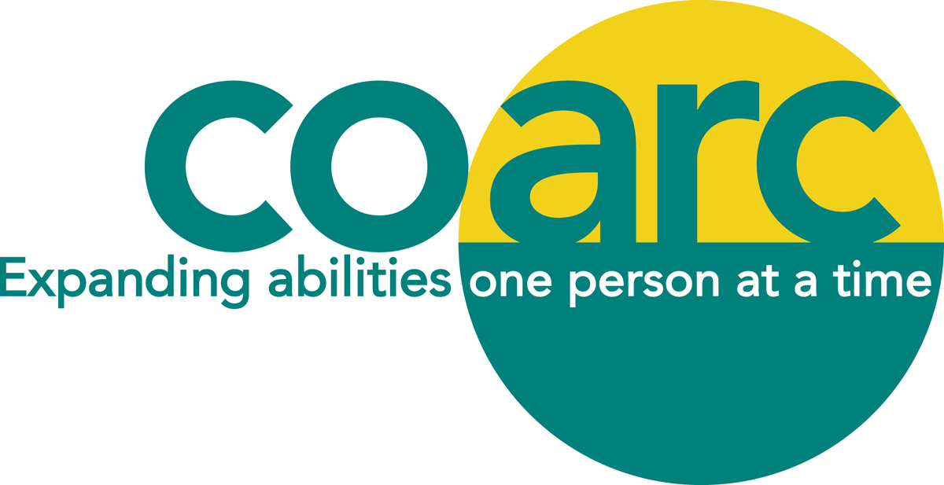

MARY MARKOWITZ MEMORIAL SCHOLARSHIP APPLICATION FORM

DESCRIPTION:
Up to two scholarships in the amount of $500 will be awarded to adult higher education students. Applicants must be residents of Columbia County or a child of a Coarc employee who have been accepted and matriculated in a college-level program of study leading to career-preparation relevant to work with people living with a disability (e.g. rehabilitation counselor, special education teacher, any allied field). Academic performance and personal recommendations will be considered in awarding the scholarships.

APPLICANT'S NAME: ______________________________________________________________________

ADDRESS:

STREET: ______________________________CITY, STATE, ZIP: __________________________________

TELEPHONE: ____________________EMAIL ADDRESS: __________________________________________

NAME AND ADDRESS OF COLLEGE WHICH APPLICANT HAS BEEN ACCEPTED OR ATTENDS:
___________________________________________________________________________________________
___________________________________________________________________________________________

MAJOR COURSE OF STUDY: ____________________________________

ANTICIPATED FUTURE OCCUPATIONAL GOAL: _____________________________________

__________________________________________________________________________________

__________________________________________________________________________________

Page 2

ACADEMIC PERFORMANCE - (Indicate class rank, any outstanding academic achievements or other relevant information. Include high school information if you have not yet begun college studies.)
___________________________________________________________________________________________

___________________________________________________________________________________________

___________________________________________________________________________________________

___________________________________________________________________________________________

___________________________________________________________________________________________

LIST EXTRACURRICULAR, COMMUNITY ACTIVITIES OR EMPLOYMENT EXPERIENCES
RELATING TO WORK WITH PEOPLE LIVING WITH A DISABILITY: ___________________________________________________________________________________________

__________________________________________________________________________________________

___________________________________________________________________________________________

___________________________________________________________________________________

LIST TWO REFERENCES AND ARRANGE FOR TWO LETTERS OF RECOMMENDATION TO BE MAILED TO COARC SCHOLARSHIPS, PO BOX 2, MELLENVILLE, NY 12544 (Applications will not be considered without these.) BY MAY 6, 2022.

___________________________________________________________________________________________
Name Address Telephone Number

___________________________________________________________________________________________
Name Address Telephone Number

IN 200 WORDS OR LESS, PLEASE WRITE A BRIEF PARAGRAPH EXPLAINING WHY YOU THINK THAT YOU SHOULD BE CONSIDERED. Please attach a separate page.

Page 3

ADDITIONAL INFORMATION THAT THE APPLICANT CONSIDERS PERTINENT TO WORKING
WITH PEOPLE LIVING WITH A DISABILITY:
___________________________________________________________________________________________

___________________________________________________________________________________________

_________________________________________________________________________________________________________________________________________________________________________________________________________________________________________________________________________________
___________________________________________________________________________________________

_________________________________ ____________________
Applicant's Signature Date

DEADLINE FOR APPLYING: MAY 6, 2022.

PLEASE MAIL COMPLETED APPLICATION FORM AND LETTERS OF RECOMMENDATION TO:
COARC SCHOLARSHIP
PO BOX 2
MELLENVILLE, NY 12544.

PLEASE NOTE:

IF YOU ARE CHOSEN AS THE RECIPIENT OF THIS AWARD AND IF THE COARC ANNUAL MEETING IS HELD IN-PERSON, YOU MUST ATTEND ON MONDAY JUNE 20, 2022 TO ACCEPT THE AWARD.

THANK YOU FOR APPLYING AND GOOD LUCK!

