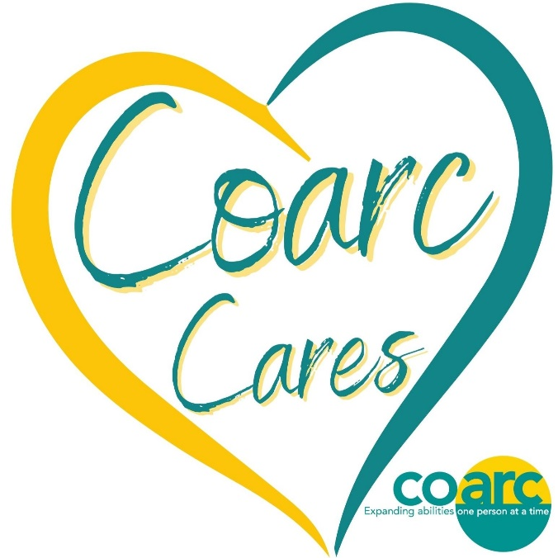
DONATION BIN - HELPING NEIGHBORS IN NEED

- Hygiene items (new only)
- Toothpaste and toothbrushes
- Hair brushes and combs
- Feminine products
- Soap & body wash
- Shampoo and conditioner
- Deodorants
- Lotions
- Washcloths
- Tissue packets
- Hand sanitizer
- Bandages
- Antibiotic ointments
- Diapers
- Baby wipes & baby care items
- Non-perishable and unexpired food items

- Winter attire for all ages & sizes (new/gently used)
- Coats
- Hats
- Gloves
- Scarves
- Socks
- Purses
- Backpacks

