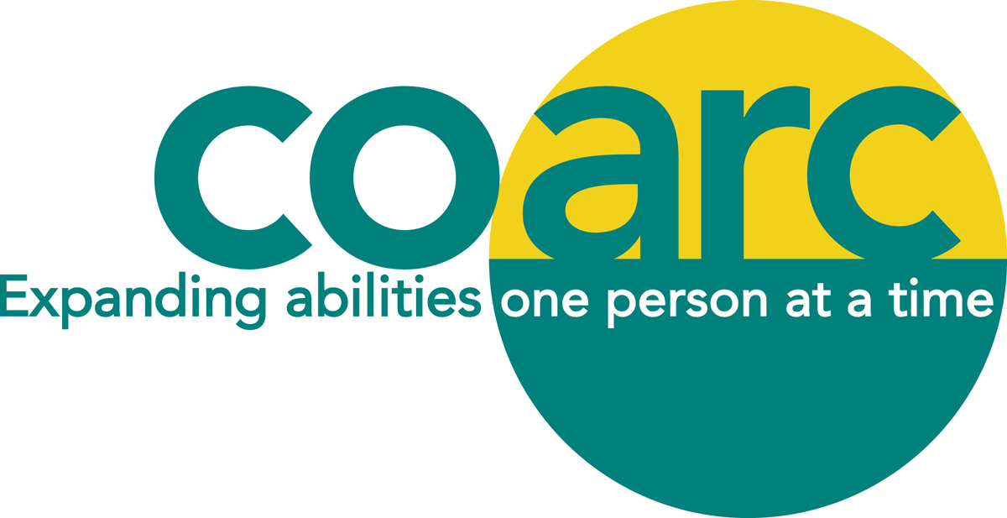

KATHELYN CASWELL MEMORIAL SCHOLARSHIP APPLICATION FORM

DESCRIPTION:
Up to two scholarships in the amount of $500 will be awarded to graduating high school students. Applicants must be residents of Columbia County or a child of a Coarc employee who have been accepted and matriculated in an undergraduate college-level program of study leading to career-preparation relevant to work with people living with a disability (e.g. rehabilitation counselor, special education teacher, any allied field). Academic performance and personal recommendations will be considered in awarding the scholarships.

APPLICANT'S NAME: _______________________________________________________________________

ADDRESS:
STREET: _________________________CITY, STATE, ZIP: ______________________________________

TELEPHONE: ____________________EMAIL ADDRESS: _________________________________________

HIGH SCHOOL CURRENTLY ATTENDING: ____________________________________________________

PARENT OR GUARDIAN: ____________________________________________________________________
(if a minor)

NAME AND ADDRESS OF COLLEGE WHICH APPLICANT HAS BEEN ACCEPTED:
___________________________________________________________________________________________
___________________________________________________________________________________________
___________________________________________________________________________________________

MAJOR COURSE OF STUDY: ____________________________________

ANTICIPATED FUTURE OCCUPATIONAL GOAL: _____________________________________

_________________________________________________________________________________

Page 2

ACADEMIC PERFORMANCE - (Indicate class rank, any outstanding academic achievements or other relevant information.)
___________________________________________________________________________________________

___________________________________________________________________________________________

___________________________________________________________________________________________

___________________________________________________________________________________________

LIST EXTRACURRICULAR, COMMUNITY ACTIVITIES OR EMPLOYMENT EXPERIENCES
RELATING TO WORK WITH PEOPLE LIVING WITH A DISABILITY: ___________________________________________________________________________________________

___________________________________________________________________________________________

___________________________________________________________________________________________

___________________________________________________________________________________________

___________________________________________________________________________________________

LIST TWO REFERENCES AND ARRANGE FOR TWO LETTERS OF RECOMMENDATION TO BE MAILED TO: COARC SCHOLARSHIPS, PO Box 2, Mellenville, NY 12544 (Applications will not be considered without these.) BY THE DEADLINE DATE OF MAY 6, 2022

___________________________________________________________________________________________
Name Address Telephone Number

___________________________________________________________________________________________
Name Address Telephone Number

IN 200 WORDS OR LESS, PLEASE WRITE A BRIEF PARAGRAPH EXPLAINING WHY YOU THINK THAT YOU SHOULD BE CONSIDERED:
Please attach on a separate page.

Page 3

ADDITIONAL INFORMATION THAT THE APPLICANT CONSIDERS PERTINENT TO WORKING
WITH PEOPLE LIVING WITH A DISABILITY:
___________________________________________________________________________________________

___________________________________________________________________________________________

_________________________________________________________________________________________________________________________________________________________________________________________________________________________________________________________________________________

_________________________________ ___________________
Applicant's Signature Date

DEADLINE FOR APPLYING: MAY 6, 2022.

PLEASE MAIL COMPLETED APPLICATION FORM AND LETTERS OF REFERENCES TO:
COARC SCHOLARSHIP
PO BOX 2
MELLENVILLE, NY 12544.

PLEASE NOTE:

IF YOU ARE CHOSEN AS THE RECIPIENT OF THIS AWARD AND IF THE COARC ANNUAL MEETING IS HELD IN-PERSON, YOU MUST ATTEND ON MONDAY JUNE 20, 2022 TO ACCEPT THE AWARD.

THANK YOU FOR APPLYING AND GOOD LUCK!

