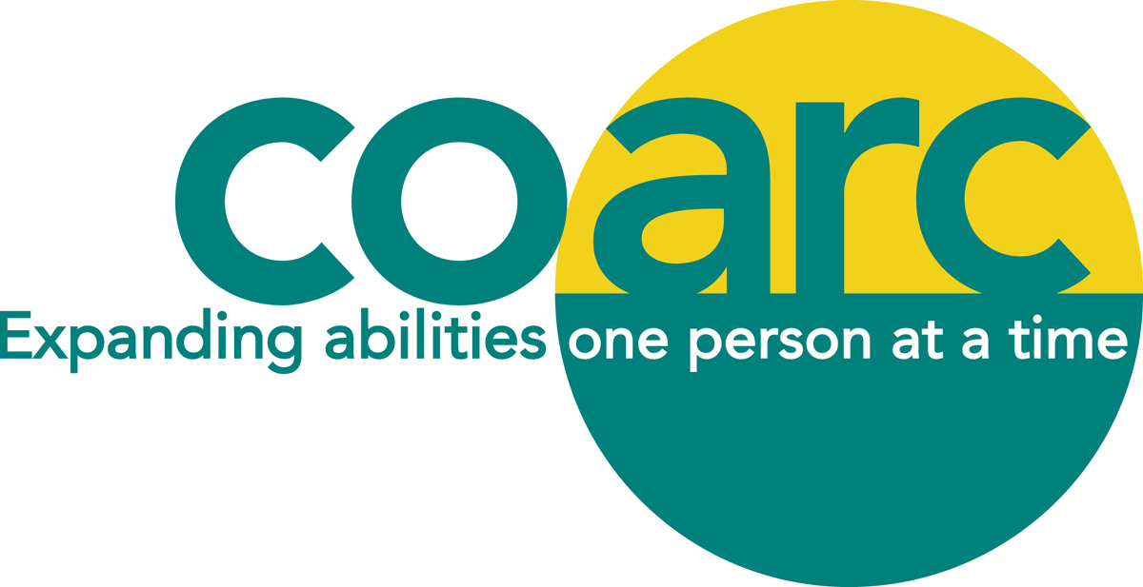

ACES DETERMINATION SCHOLARSHIP APPLICATION FORM

DESCRIPTION:
Up to two ACES Determination scholarships, each in the amount of $500 will be awarded to graduating high school students living with a disability. Applicants must be residents of Columbia County or a child of a Coarc employee who have been accepted and matriculated in an undergraduate college-level program of study. Applicants must have a current Individual Education Plan (IEP) or 504 Plan on file with their school district and verification of this must be sent by the school district. Academic performance and personal recommendations will be considered in awarding the scholarships.

APPLICANT'S NAME: _____________________________________________________________________
ADDRESS:
STREET: ____________________________CITY, STATE, ZIP: ________________________________

TELEPHONE: ___________________ EMAIL ADDRESS: ________________________________________
HIGH SCHOOL CURRENTLY ATTENDING: __________________________________________________
PARENT OR GUARDIAN (if a minor): _________________________________________________________________________________

NAME AND ADDRESS OF COLLEGE WHICH APPLICANT HAS BEEN ACCEPTED:
___________________________________________________________________________________________
___________________________________________________________________________________________
MAJOR COURSE OF STUDY: _____________________________________________________________
ANTICIPATED FUTURE OCCUPATIONAL GOAL: __________________________________________

Page 2
ACADEMIC PERFORMANCE - (outstanding academic achievements or other relevant information.)
___________________________________________________________________________________________
___________________________________________________________________________________________
___________________________________________________________________________________________
___________________________________________________________________________________________
LIST EXTRACURRICULAR, COMMUNITY ACTIVITIES OR EMPLOYMENT EXPERIENCES: ___________________________________________________________________________________________
___________________________________________________________________________________________
___________________________________________________________________________________________
___________________________________________________________________________________________
LIST TWO REFERENCES AND ARRANGE FOR TWO CURRENT LETTERS OF RECOMMENDATION TO BE MAILED TO COARC SCHOLARSHIPS, PO BOX 2, MELLENVILLE, NY 12544 BY MAY 6, 2022 (Applications will not be considered without these.):
___________________________________________________________________________________________
Name Address Telephone Number
___________________________________________________________________________________________
Name Address Telephone Number

PLEASE WRITE A BRIEF ESSAY ON A SEPARATE PAGE IN 200 WORDS OR LESS EXPLAINING WHY YOU THINK THAT YOU SHOULD BE CONSIDERED. YOUR STATEMENT MAY INCLUDE:
- A DESCRIPTION OF YOUR EDUCATIONAL EXPERIENCES SO FAR, INCLUDING BARRIERS OVERCOME AND OPPORTUNITIES REALIZED
- AN OUTLINE OF YOUR EDUCATIONAL AND CAREER GOALS

Page 3
ADDITIONAL INFORMATION THAT THE APPLICANT CONSIDERS PERTINENT TO WORKING
WITH PEOPLE LIVING WITH A DISABILITY: (Optional)
___________________________________________________________________________________________
___________________________________________________________________________________________
___________________________________________________________________________________________
___________________________________________________________________________________________
___________________________________________________________________________________________
___________________________________________________________________________________________
___________________________________________________________________________________________
___________________________________________________________________________________________

_________________________________ ____________________
Applicant's Signature Date

DEADLINE FOR APPLYING: MAY 6, 2022
PLEASE MAIL COMPLETED APPLICATION FORM, LETTERS OF RECOMMENDATION AND LETTER OF VERIFICATION OF IEP OR 504 STATUS FROM YOUR SCHOOL DISTRICT TO:
COARC SCHOLARSHIP
PO BOX 2
MELLENVILLE, NY 12544

PLEASE NOTE:
IF YOU ARE CHOSEN AS THE RECIPIENT OF THIS AWARD AND IF THE COARC ANNUAL MEETING IS HELD IN-PERSON, YOU MUST ATTEND ON MONDAY JUNE 20, 2022 TO ACCEPT THE AWARD.

THANK YOU FOR APPLYING AND GOOD LUCK!

