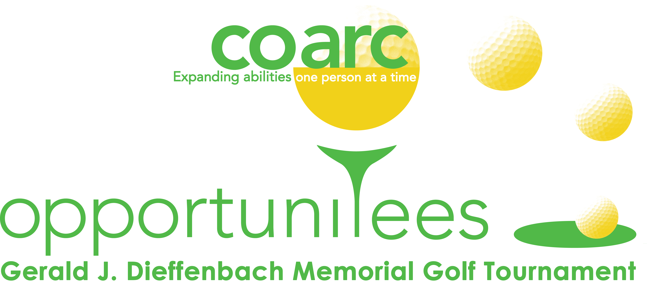
2021 SPONSORSHIP LEVELS
Coarc OpportuniTees Golf Tournament
Thursday, September 23, 2021 (Rain Date:September 30)
Copake Country Club, Copake Lake, New York

Platinum Sponsorship - $5000:
Includes: One free foursome, exclusive event signage, Flag & Tee signage, optimal placement on promotional signage & materials, Coarc Membership, opportunity to provide promotional gift(s), inclusion in Coarc Press Release.
Gold Sponsorship - $3000:
Includes: One free foursome, prominent signage, Flag & Tee signage, prominent placement on promotional signage & materials, Coarc Membership, opportunity to provide promotional gift(s), inclusion in Coarc Press Release.
Silver Sponsorship - $2000:
Includes: Two free golfers, Tee & Flag signage, Coarc Membership, opportunity to provide promotional gift(s), inclusion in Coarc Press Release.
Bronze Sponsorship - $1000:
Includes: One free golfer, Tee & Flag signage, Coarc Membership, opportunity to provide promotional gift(s), inclusion in Coarc Press Release.
Cart Sponsorship - $1000:
Includes: One free golfer, Tee & Flag signage, logo promotion in every golf cart, Coarc Membership, opportunity to provide promotional gift(s), inclusion in Coarc Press Release.
Green Sponsorship - $200:
Sponsorship includes both Tee & Flag signage (please note, Flag signage will be displayed on the club grounds or course), Coarc Membership, and opportunity to provide promotional gift(s).
Tee Sponsorship - $100:
Tee Signage, Coarc Membership, and opportunity to provide promotional gift(s).
Other Sponsorship - Variable:
Please contact us for details about other first come first served opportunities which include Cocktail Hour, Beverage Cart, Snack Shack, Golf Ball, and Golden Ticket sponsorships.

Golf Sponsorship Tear Sheet Sponsorship includes Coarc membership. If you would prefer not to be a Coarc member please check here: 
Company/ Sponsor: __________________________________________________________________________

Contact Person: ______________________________________________________________________________

Address: ______________________________________________________________________________________
Telephone: ___________________________________ Email: _________________________________________
Sponsorship Level: ___________________________________ Sponsorship Amount: $_____________
Please Make Check Payable to: Coarc
Credit Card MC or Visa _____________________________________________________ Exp ______________
Authorized Signature: _________________________________________________________________________
Please reuse my 2019 sign(s): check here 
Please list my signage (new/changes) as: _________________________________________________
I will provide promotional gifts for golfers: contact me 

Please Fax or Mail this completed form with remittance to:

Coarc Golf Tournament, PO Box 2, 630 Route 217, Mellenville, NY 12544
Phone: (518) 672-4451 * Fax: (518) 672-0187 * www.coarc.org * info@coarc.org
-

Coarc is a 501(c)(3) nonprofit organization. Your sponsorship is tax deductable to the amount allowable by law.

