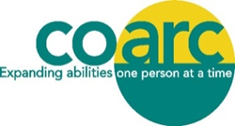
You Create Possibilities…
Become a Member!
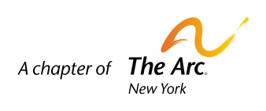

2018 Membership Drive
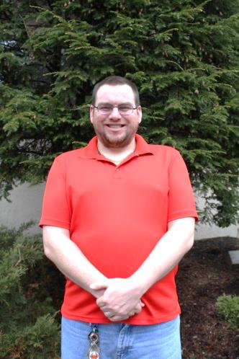
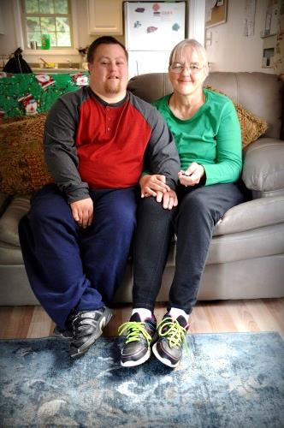
Dear Friends,

For over 50 years, Coarc has supported people with disabilities in our community. We could not do it without you. With your help, Russell has a full-time job and is proud to be earning a paycheck. Jace struggled to engage with others, now he enjoys talking and playing with his peers. Mark and Mary Ellen Harris live in a home of their own. Roman, with support from his staff, climbed a mountain!

This year, more than ever, renewing your membership or becoming a new member is vital to the work we do. If you believe in our mission, we ask that you show your support today.

With your membership, we will continue to create possibilities. Together, we can protect the rights of people with disabilities and support their full inclusion and participation in the community. Your membership matters. Together, let’s make our voice heard!

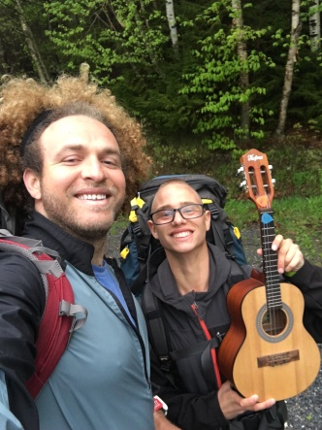


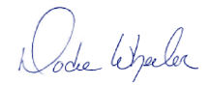
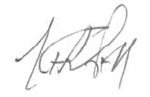
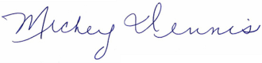

Become a Friend of Coarc online at www.coarc.org by visiting the “Donate Now” link or mail this form with your payment information to: Coarc, PO Box 2, Mellenville, NY 12544

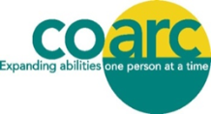
Yes! I want to be a member of Coarc for 2018 to support Coarc programs and services!

Your donation includes membership in The Arc New York, Inc. and The Arc of the United States. Membership lists are not shared or sold for use by other outside organizations or for solicitations.

Join online at www.coarc.org or return this completed form with payment to: Coarc, P.O. Box 2, Mellenville, NY 12544

$500 $250 $100 $50 $25 $10 I would like to be a sustaining member. Charge my credit card $_______ monthly.
Please send me information about the Arc New York Charitable Gift Annuity Program.

Please list your name(s) as you wish to be recognized. I wish to remain anonymous.
Name (s):
Address: |  |  |  |  |  |  |  |  |  |  |  |  |  |  |  |  |  |  |  | City, State, Zip:
Phone: |  |  |  |  |  |  |  |  |  |  |  |  |  |  |  |  |  |  |  |  | Email, please:
 | Enclosed is a check payable to Coarc in the amount of: |  |  |  |  |  |  |  |  |  |  |  |  |  |  |  | $
 | Master Card |  |  |  |  |  |  |  |  | Visa | # |  |  |  |  |  |  |  |  |  |  | CVV # |  |  | Exp. Date:
 | Amount: |  |  |  |  | $ |  |  |  |  |  |  |  |  | Authorized Signature:
This gift is |  |  |  |  |  |  |  |  | in memory of: |  |  |  |  | in honor of:

Coarc is a 501(c) (3) nonprofit organization, the Columbia County chapter of The Arc New York, Inc., and a member of The Arc of the United States.
Coarc • P.O. Box 2, 630 Rt. 217, Mellenville, NY 12544 • Phone: 518-672-4451 • Fax: 518-672-0187 • www.coarc.org • info@coarc.org • Coarc is on Facebook 

Our Programs & Services
Advocacy
Camp Mahican
Clinical Services
Contract Manufacturing
Community Employment Services
Community Habilitation Services
Day Habilitation Services
Recreation Opportunities
Residential Services
Respite Program
Self-Directed Services
The Starting Place Preschool & Day Care
Transitions Program
Tradewinds Retail Store

Please join us for our Annual Membership Meeting
Coarc’s Cardinal Hall
350 Fairview Ave, Hudson, NY 12534
Monday June 18, 2018, 6:00-7:30 p.m.
Nominating Committee, 2018-2019
Annette Dennis, Mary Ann Harris, Doris Meier
A copy of our latest annual report may be obtained upon request from:
Coarc, P.O. Box 2, 630 Route 217, Mellenville, NY 12544

Directors Remaining on the Board, Second Year of a Two-Year Term, 2017-2019
John Craft Karen Engel Donna Knight Priscilla Moore
Annette Dennis Mary Ann Harris Doris Meier Dorothy Wheeler
THE NOMINATING COMMITTEE PRESENTS
The 2018 Slate of Officers, Directors and Nominating Committee
Officers 2018-2019
President: Mary Anne VanDenburgh
Vice President: Donna Knight
Secretary: Tracy Cantele
Treasurer: Dorothy Wheeler
Directors for Two Year Terms, 2018-2020
Denise Barry
Mary Blass
Tracy Cantele
Mary Anne VanDenburgh
Expanding abilities in Columbia County since 1965, one person at a time, supporting 500 people with disabilities to achieve their individual goals.

