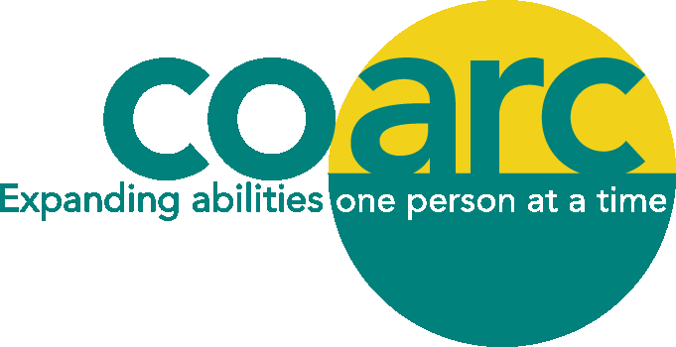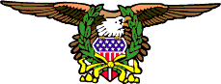

A.B.A.T.E. of New York, Inc.

Columbia County Chapter

Spring 2019

Dear Friends,
We are hosting the second annual Coarc Abate Fundraiser on Sunday, July 14, 2019. This fundraiser raises funds that help to ensure the continued delivery of Coarc programs and services for people with disabilities, supporting them to lead the most independent lives possible.

Participants at the fundraiser enjoy buying raffle tickets after the ride to win donated items, a fun activity that significantly adds to the funds we raise that day. Please consider donating merchandise or a gift certificate for the Coarc Abate Fundraiser raffle by June 30, 2019. Our raffle donation form is enclosed.
This is a great promotional opportunity! Raffle donors will be recognized in signage. Donors will also be acknowledged on our fundraiser events page of www.coarc.org.
Coarc is a 501(c)(3) nonprofit charitable organization, so your donation is tax deductible to the amount allowable by law. Your support through the donation of a gift certificate or merchandise to our fundraising raffle will help us fulfill our mission to expand abilities, one person at a time, so individuals experiencing disabilities can achieve their individual goals.
If you have any questions or need an item picked up, please contact Danielle Palleschi at 518-378-5136 or daniellep@coarc.org. Thank you for your consideration and support.

2019 Abate Fundraiser
Hudson/Claverack Town Park July 14, 2019

Raffle Donation
Please list the way you wish to be acknowledged and complete your mailing address in full:

Company __________________________________________________________________________
Contact Person _____________________________________________________________________
Mailing Address_____________________________________________________________________
_____________________________________________________________________
Telephone __________________________________________________________________________
Email _______________________________________________________________________________
Website ____________________________________________________________________________
□ Gift Certificate □ Item/Merchandise Declared Value of Donation $ _____________
Description of Donation ______________________________________________________________
_____________________________________________________________________________________
_____________________________________________________________________________________
_____________________________________________________________________________________
_____________________________________________________________________________________

_____________________________________________________________________________________
_____________________________________________________________________________________

Delivery of Donation: □ Enclosed with this form
□ Call me at the phone # below to arrange pick-up
□ I will deliver it to Coarc by June 30, 2019

Please fax or mail this completed form by June 30, 2019 to
Danielle Palleschi
Coarc Abate Fundraiser
Fax: (518) 672-0187
Phone: (518) 378-5136
Email: daniellep@coarc.org

Coarc is a 501(c)(3) non-profit charitable organization. Your in-kind donation is tax deductible to
The amount allowable by law. Please contact us for more information about Coarc at
518-672-4451, info@coarc.org or www.coarc.org.

